Network Packet Capture, Analysis

Domain:
Cyber Security – Blue Team / SOC Fundamentals
Tools Used:
Kali Linux, Wireshark, Tshark, packETH

Introduction
Understand how network traffic is captured, analyzed, and replayed in a controlled environment.
This practice helps in learning how Security Operations Center (SOC) teams monitor and analyze network-level events for detection and troubleshooting.

Objectives
The main objectives of this lab are:
- To verify network connectivity
- To capture ICMP traffic using Wireshark
- To analyze packet details at the network layer
- To convert PCAPNG files into PCAP format
- To replay captured packets using packETH

To understand basic IDS traffic simulation concepts

Lab Environment
Operating System:
- Kali Linux

Tools :
- Wireshark
- Tshark
- packETH
Network Interface Used:
- eth0

Step-by-step Implementation
Step 1: Network Connectivity Check
Command Used
ping 8.8.8.8 -c 3
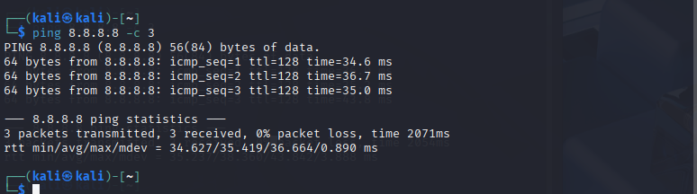

Step 2: ICMP Traffic Capture Using Wireshark
Wireshark was used to capture ICMP packets generated by the ping command.
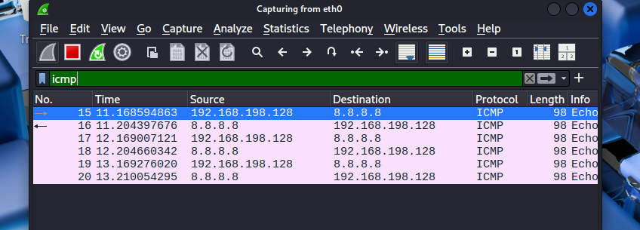

Step 3: Conversion
Pcapng file into pcap
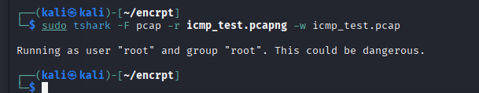

Step 4: Confirm PCAP file exist or not
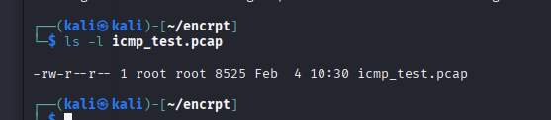

STEP 5: Install packet
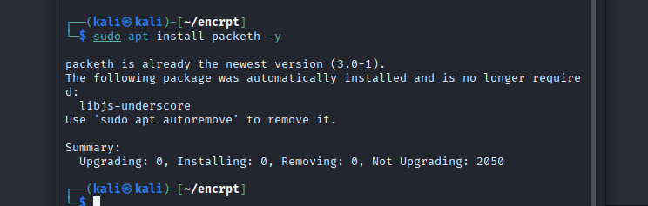

Step 6: Packet Replay (Mode 1)
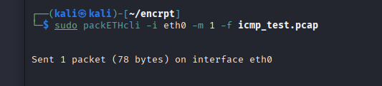

Step 7: Multiple Packet Replay (Mode 2)
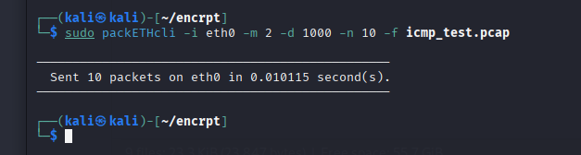

STEP 8: IDS Rule File Creation

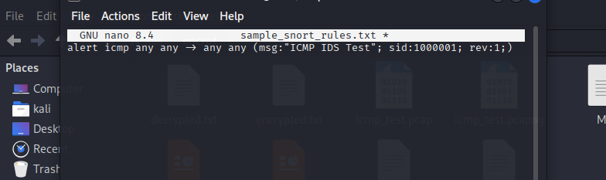

STEP 9: IDS Traffic Simulation (packETH Mode 5)
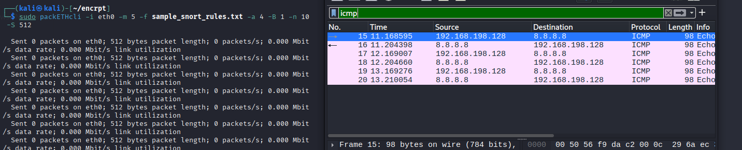

Conclusion
In this lab, we successfully captured, analyzed, and replayed ICMP network traffic in a controlled environment using Kali Linux tools.
We learned how network packets are generated, monitored, and tested from a defensive (Blue Team) perspective.
The lab demonstrated the importance of packet capture and replay in SOC operations, especially for troubleshooting, alert validation, and IDS testing.
Tools like Wireshark, Tshark, and packETH play a critical role in understanding real network behavior and improving detection capabilities.
This hands-on practice strengthened foundational knowledge of network security monitoring and provided practical exposure to SOC-level workflows.

For my self
Tum sirf ye bolo ??
I performed a hands-on lab where I captured ICMP network traffic using Wireshark, converted and replayed packets using Tshark and packETH, and simulated basic IDS traffic. This helped me understand SOC-level network monitoring and defensive testing workflows.
1?? IS LAB MEIN HUMNE KYA KIYA? (Simple Explanation)
Tumhari lab ka overall kaam ye tha:
?? Humne network traffic (ICMP) ko
" pehle generate kiya
" phir capture kiya
" usko analyze & convert kiya
" aur baad mein dobara replay / simulate kiya
Ye exactly wahi process hai jo SOC (Security Operations Center) mein hota hai jab:
" alerts investigate kiye jaate hain
" suspicious traffic ko test kiya jaata hai
Simple words mein:
Humne ek real network packet ko pakra, samjha, aur phir usi packet ko test ke liye dobara network par bheja.
________________________________________
2?? STEP-WISE: HUMNE KYA KYA KIYA (ONE-BY-ONE)
Tum Word file mein ye explanation "Overview" ya "What We Did" ke section mein daal sakte ho ??
? Step 1: Network Connectivity Check
Humne sab se pehle ye check kiya ke system internet se connected hai ya nahi, ICMP packets send ho rahe hain ya nahi.
? Step 2: ICMP Traffic Capture
Ping command se ICMP traffic generate kiya aur Wireshark ki madad se us traffic ko capture kiya.
? Step 3: File Format Conversion
Captured traffic PCAPNG format mein tha, jisko humne Tshark use karke PCAP format mein convert kiya, taake replay tools ke saath compatible ho.
? Step 4: Packet Replay
packETH tool ka use karke:
" ek packet bheja (Mode 1)
" multiple packets bheje (Mode 2)
? Step 5: IDS Rule Creation
Nano editor ke through ek simple IDS rule file banayi jo ICMP traffic ko detect karti hai.
? Step 6: IDS Traffic Simulation
packETH ke IDS mode (Mode 5) ke zariye rule-based ICMP traffic simulate kiya taake IDS testing ka concept samajh aa sake.

